Project One

A manufacturing company located in Tijuana, Mexico is noticing an increase in defects of their welding process of electric boards and in the components named Thru-Holes after an increase in demand. The defects include the solder bridge, missing components, damaged components, lifted components, insufficient solder, and excessive solder. These defects are being discovered after the boards have gone through the final assembly process which requires increased costs, production hours, and specially qualified workers in order to correct the defects. This manufacturing company seeks to comply with standards that were established by the IPC-A-610E which requires them to correct the defects before the release of their products.

A project has been requested to improve the defects with two outcomes including, “A 20% reduction in the defects generated during the welding process in the double production lines of the Manual Finish area. The second outcome is a 20% increase in the capacity of the three double production lines where electronic boards are processed, without the percentage of defects” (DAT475 Project Case Study, 2023).

**Problem Statement**: In order for the manufacturing company to decrease the number of defects they are producing after the final assembly process, the organization must adhere to industry’s best standards by correcting the defects prior to their release. This entails a 20% reduction in defects produced from the welding process as well as a 20% increase in the capacity of the production line. By completing these improvements, the manufacturing company can enhance the product quality to decrease defects, increase organizational efficiency, and reduce costs. If not addressed, the defects will continue to increase, potentially leading to loss of sales and customers due to a reputation of producing poor quality products.

**Model: 595407-XXX-00**

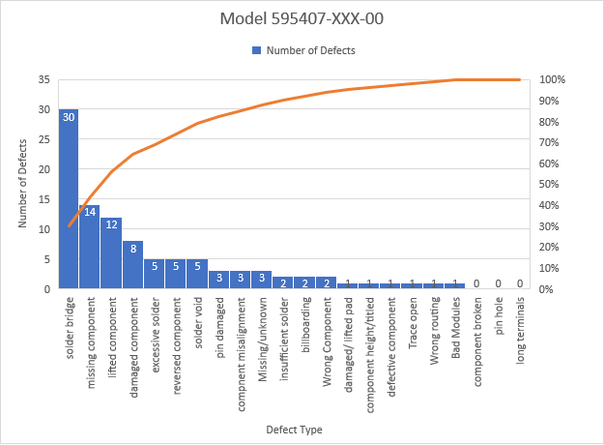

This model portrays the number of defects in blue and the orange line represents the cumulative percentage of the number of defects. The top 20% of defects in this model are solder bridge, missing component, lifted component, and damaged component. The defect types: component broken, pin hole, and long terminals have 0 defects.

**Model: 595481-00X-00**

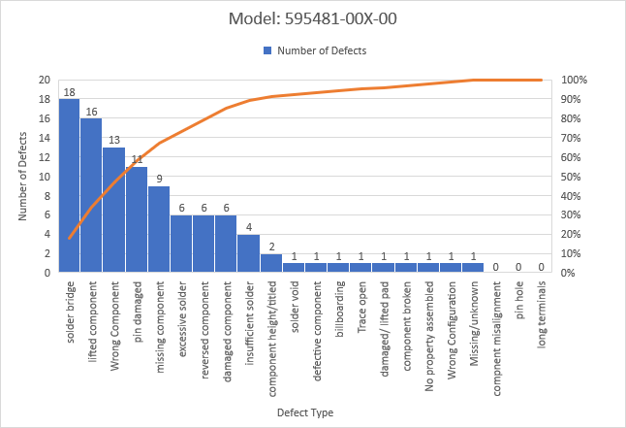

The number of defects in the chart for this model are displayed in blue and the cumulative average is in orange. The top 20% of defects in this model are solder bridge, lifted component, wrong component, pin damaged, missing component, excessive solder, reversed component, damaged component, and insufficient solder. The defect types with 0 defects are component misalignment, pin hole, long terminals.

**Model: 595310-001-00**

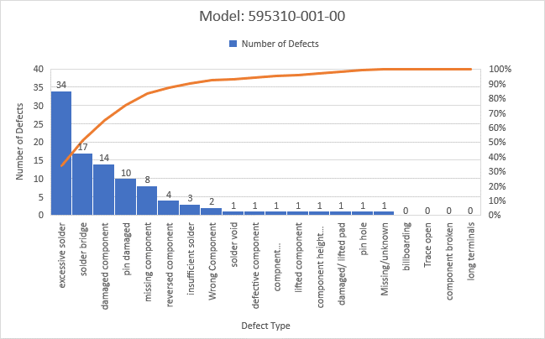

This model also utilizes blue to portray the number of defects and orange to display the cumulative average. The top 20% of defect types in this model are excessive solder, solder bridge, damaged component, pin damaged, and missing component. The defect types with 0 defects in this model are billboarding, trace open, component broken, and long terminals.

Each chart summarizes the top 20% of defects for each of the three models. This provides insight into the root cause by comparing the 80/20 ratio to the defects, revealing that 80% of the defects stem from 20% of the causes. These charts offer a visual representation and enable us to prioritize the issues that, when addressed, can contribute to achieving the 20% defects in each area in the facility as well as our second objective of a 20% increase in output production. We can use the list of defects in the top 20% for each model and overall to prioritize our efforts and focus on the ones with the most significant impact on the overall defect rate.

The fishbone diagram illustrates potential issues that are contributing to the root cause of the product defects. It is possible the defects are a result of human error characterized by improper training and insufficient personnel. The facility may not have enough workers to fulfill the influx of orders and is providing minimal training to get employees working as soon as possible. Additionally, the facility may be utilizing equipment that is inappropriate or even broken to create the products. The facility may not want to allocate time to provide maintenance to the equipment so it will not fall behind target production numbers.

The quality of the products may also be lacking due to poor sample check frequency, no End-Of-Line (EOL) tester, no automation inspections, or appropriately adhering to the policies in the Standard IPC-A-610E. The facility may not be utilizing an employee or a machine to test each product before sending it to the next step or prior to the final phase in production. There may also be issues during the process such as mishandling of the product, poor solder machine calibration, and hasty individual takt times. It is possible that the workers are moving too quickly to decrease their individual takt times and complete orders rapidly. This can lead to not handling the products carefully which can cause many defects. Additionally, if the solder machine is poorly calibrated, it can produce issues such as insufficient or excessive soldering. Overall, by understanding the root cause, we can address the core issues of the defects and make more effective and sustainable improvements.

Tableau Dashboard

This interactive dashboard, created using Tableau, provides a comprehensive view of the defect type sum versus the percentage, the overall percentage of defect type, and the defect type percentage per model. The labels are on the right-hand side showing the percentage is grey and the lightest color blue signifies a lower sum of defects while the darker shade signifies a large sum of defects.

The top portion portrays the effect type per model in a bar graph. The sum of defects is in a shade of blue and the percentage is in grey. The black line signifies the average percentage. The pie chart in bottom left corner displays the average percentage of each defect type of all three models. The bar graph next to it on the right shows the defect type percentage per model.

Model 1 has a significantly higher percentage of defects compared to the other two models. The defect type, solder bridge, makes up almost half the number of defects at 43.9%.

Project Two

A hypothesis test needs to be conducted in order to understand if there is a statistically significant difference in the percentage of defects in comparison to the other two production lines. If a statistically significant difference does exist, it will indicate that the production lines with the highest number of defects should have those defects corrected. We will use data from production with the highest number of defect percentage to conduct the hypothesis test. Our data is displayed in the table below:

|  |  |  |
| --- | --- | --- |
| **Model 1** | **Model 2** | **Model 3** |
| 30 | 6.67 | 7.23 |
| 14 | 3.11 | 3.37 |
| 11.5 | 2.56 | 2.77 |
| 8 | 1.78 | 1.93 |
| 5 | 1.11 | 1.2 |

Defining the null and alternative hypothesis:

**Null Hypothesis (H0):** There is no significant difference between the means μ1=μ2=μ3

**Alternative Hypothesis (Ha):** There is at least one significant difference between the means. (μ1≠μ2≠μ3) α = 0.05

We will conduct a One-way Analysis of Variance (ANOVA) hypothesis test to determine if we have sufficient evidence to reject or accept the null hypothesis. The parameters used for this test are the models as the independent variable and the defects percentage as the dependent variable. These parameters were chosen as the results derived from using these parameters are most relevant to solving the organizational problem. In order to conduct the ANOVA test, I uploaded the data into the SPSS software. Next, I transformed the variable, model, into a numeric value so that it would appear in the dialogue box. I then selected analyze, compare means, and chose the One-Way ANOVA test. Then, I placed percentage in the dependent list and model as the factor. I chose Tukey as the equal variance assumed and used 0.05 as the significance level from the Post Hoc section. I also selected the box for descriptive under the options section. Finally, I ran the test and received the following results:

The One-Way ANOVA test produced results for sum of squares, degree of freedom, mean square, F-statistic, and the significance, or p-value. The F-statistic is 5.285 and the significance, or p-value, is 0.023. Since we are using a level of significance of 0.05 and our p-value is less than that at 0.023, we can reject the null hypothesis that there is no significance between the three means. The results for the Post Hoc Tests are listed below:

|  |  |  |  |
| --- | --- | --- | --- |
| **(I) Model** | **(J) Model** | **P-Value** | **Result** |
| Model 1 | Model 2 | 0.036 | There is no significant difference. We fail to reject the null hypothesis. |
| Model 1 | Model 3 | 0.041 | There is no significant difference. We fail to reject the null hypothesis. |
| Model 2 | Model 1 | 0.036 | There is no significant difference. We fail to reject the null hypothesis. |
| Model 2 | Model 3 | 0.997 | The is a significant difference. We reject the null hypothesis. |
| Model 3 | Model 1 | 0.041 | There is no significant difference. We fail to reject the null hypothesis. |
| Model 3 | Model 2 | 0.997 | The is a significant difference. We reject the null hypothesis. |

References

*Libguides: SPSS tutorials: One-way anova*. One-Way ANOVA - SPSS Tutorials - LibGuides at Kent State University. (n.d.). https://libguides.library.kent.edu/spss/onewayanova

*One-way ANOVA in SPSS statistics*. One-way ANOVA in SPSS Statistics - Step-by-step procedure including testing of assumptions. (n.d.). https://statistics.laerd.com/spss-tutorials/one-way-anova-using-spss-statistics.php

*Fishbone diagram*. Fishbone Diagram - MN Dept. of Health. (n.d.). https://www.health.state.mn.us/communities/practice/resources/phqitoolbox/fishbone.html

*How to conduct a root cause analysis*. The Compass for SBC. (2022, April 21). https://thecompassforsbc.org/how-to-guide/how-conduct-root-cause-analysis

Project One Guidelines and Rubric. (n.d.) Retrieved July 16, 2023 from https://learn.snhu.edu/d2l/le/content/1346991/viewContent/25000714/View